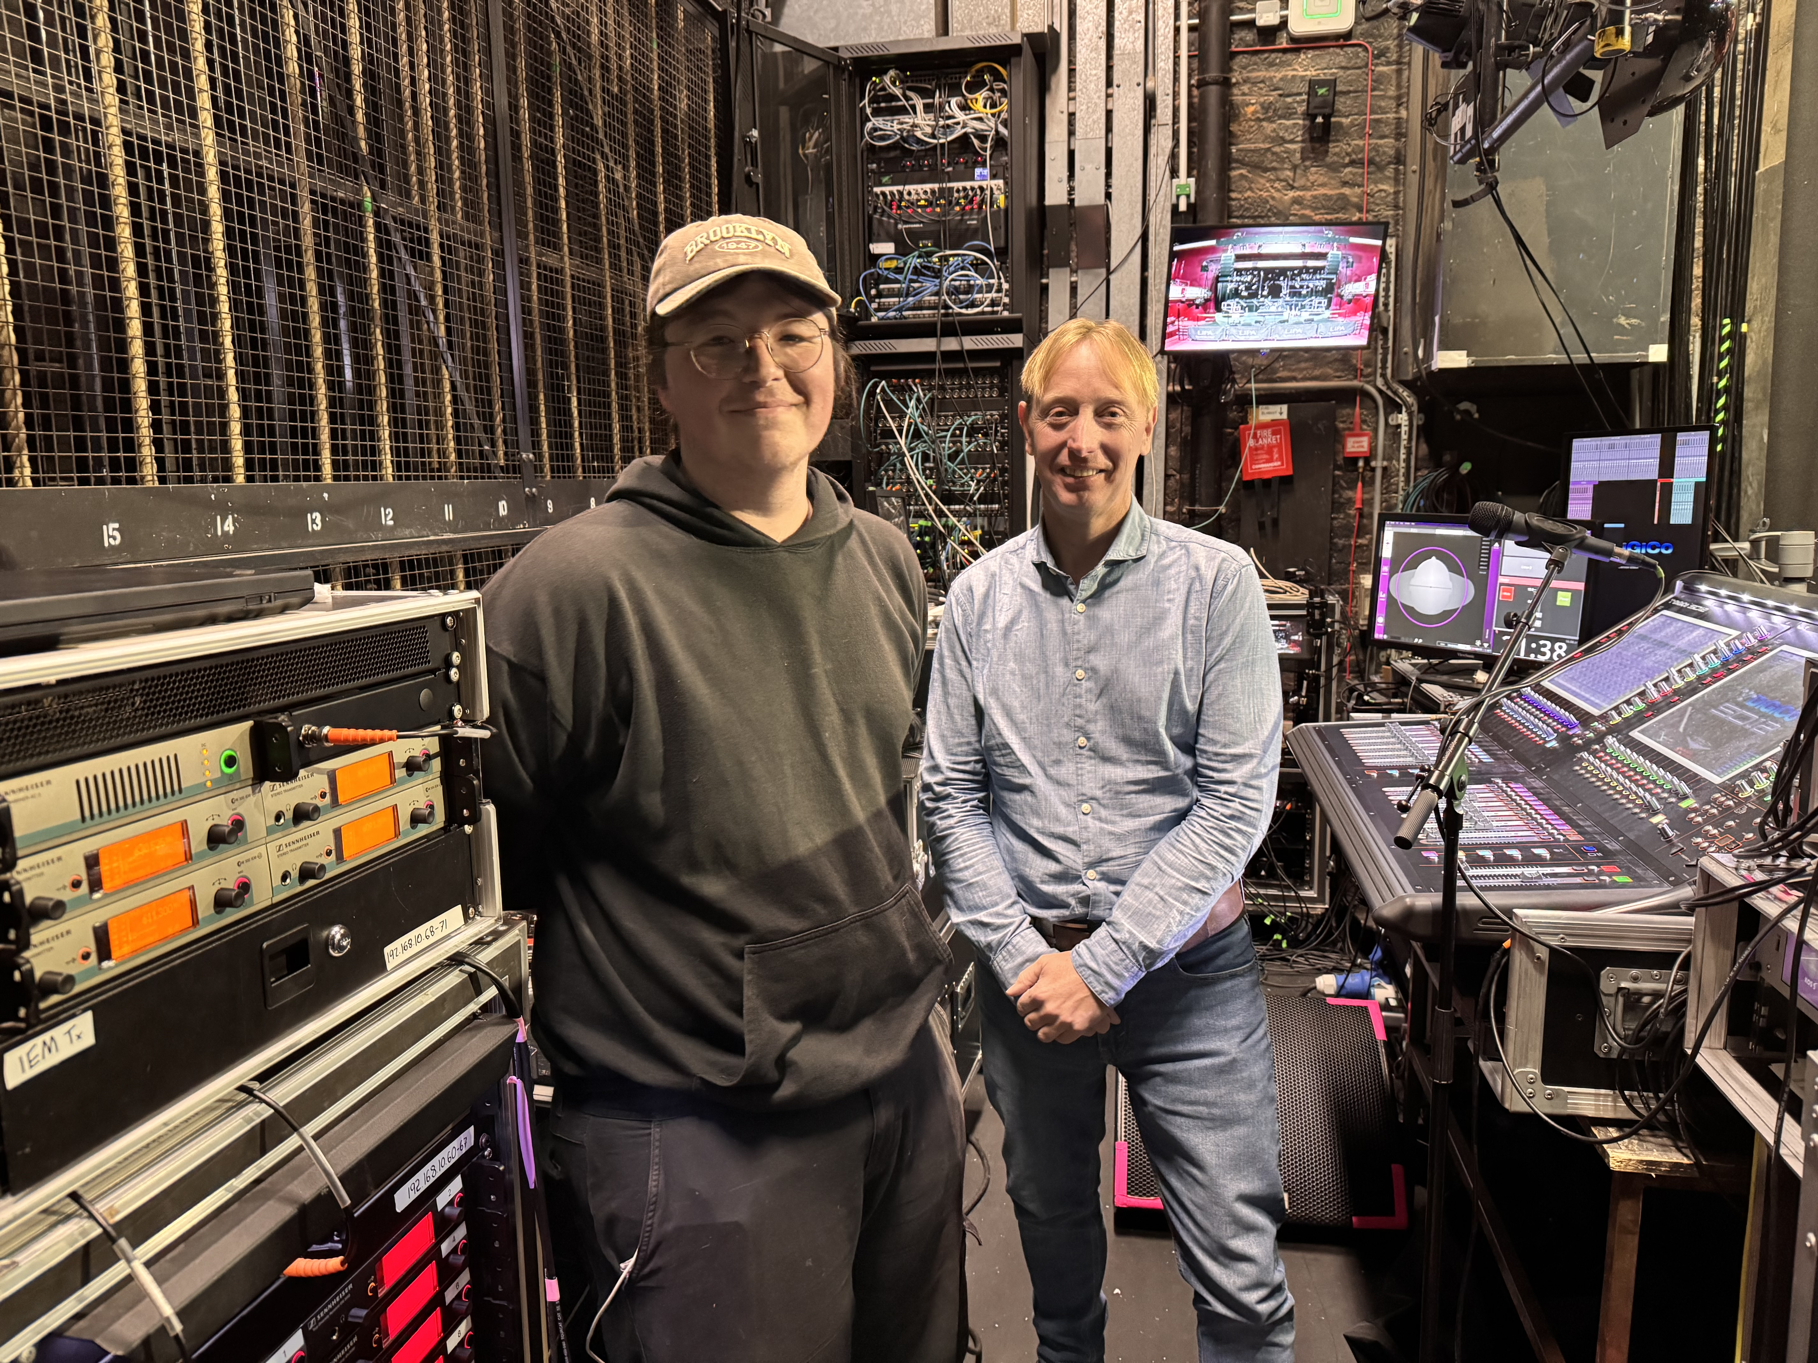
Josh Dooley becomes 30th winner of Sennheiser LIPA Scholarship
The prestigious programme empowers students by developing their skills and expanding their networks via collaboration with industry professionals worldwide
Marlow, UK, June 2025 - Celebrating three decades of partnership between The Liverpool Institute for Performing Arts (LIPA) and Sennheiser, the global audio specialist continues its commitment to nurturing emerging talent through the Sennheiser Student Scholarship programme. This long-standing collaboration provides students with access to world-class audio expertise and industry resources, and Josh Dooley, a BA (Hons) Sound Technology student whose remarkable journey demonstrates extraordinary resilience and passion for audio engineering, has been selected as the 2025 scholarship recipient. His inspiring story of overcoming significant personal obstacles to pursue his musical ambitions captivated the judging panel, featuring Tim Sherratt, Strategy Manager at Sennheiser, and acclaimed theatre sound designer, Ben Harrison.
Growing up in a disadvantaged area of Merseyside, Dooley's journey into sound engineering has been shaped by both passion and perseverance. Diagnosed with Tourette's syndrome, severe ADHD, and dyspraxia at age eight, he found refuge in music when his conditions made traditional education challenging. "By the age of 14, my tics had become extremely severe, but when I played the guitar or mixed live sound, my tics would subside, allowing me to focus fully on something I was passionate about," Dooley explains.
Despite limited resources, Dooley's determination led him to innovative solutions. Unable to afford new equipment, he turned to second-hand gear and DIY projects, working with his uncle to build musical devices including an electric guitar and pedals. At 15, he began buying broken microphones to repair and enhance, developing a deep understanding of audio capture and recording through hands-on experimentation.
Dooley's practical experience began early, assisting his uncle, a radio DJ, with venue setups as a teenager. This evolved into formal training at 16 through an afterschool sound technology course at a local music venue, where he learned to operate sound desks and lighting equipment. His skills quickly advanced, leading to a position running sound for open mic nights and eventually teaching others to use the same equipment.
At 18, Dooley participated in a documentary about living with Tourette's syndrome, which connected him with professional producers and mix engineers. "I continued shadowing them, gaining invaluable insight into recording techniques and studio workflows," he says. This experience, combined with his A-level studies, led to his acceptance at LIPA.
Currently, Dooley balances his studies with work as an assistant to producers at Catalyst Studio in Saint Helens, where he's learning studio mixing and acoustic treatment techniques.
Joined by Ben Harrison, an experienced sound designer best known for his work on West End productions and large-scale touring musical productions, Sennheiser’s Tim Sherratt had the task of selecting a student who embodied the scholarship's ethos.
"Josh's application stood out not just for his technical abilities, but for his innovative approach to problem-solving and his genuine dedication to making music and sound accessible to others,” explains Harrison. “His experience with unconventional recording techniques and DIY solutions demonstrates exactly the kind of creative thinking we want to nurture."
"Winning the Sennheiser scholarship means everything to me," Dooley reflects. "It provides financial freedom that will let me focus on my studies and pursue projects for experience rather than just financial necessity. In four years' time I hope to be working with microphones, developing, tweaking and testing new products. Alongside this, I would love to be a freelance producer and mixing engineer for artists that cannot afford professional production services. I know how expensive and hard it is to create music without sufficient funds, and I want to help disadvantaged bands and singers who want to enter the industry."
The scholarship will provide Dooley with financial support, access to Sennheiser's international network, industry events, and in-depth product knowledge that will be invaluable as he builds his career in sound engineering and music production.
Sherratt concludes: "Josh’s story shows how passion and determination can overcome significant obstacles, and we're excited to support his journey in the audio industry."
(Ends)

About the Sennheiser Brand – 80 Years of Building the Future of Audio
We live and breathe audio. We are driven by the passion to create audio solutions that make a difference. This passion has taken us from the world’s greatest stages to the quietest listening rooms – and made Sennheiser the name behind audio that doesn’t just sound good: It feels true. In 2025, the Sennheiser brand celebrates its 80th anniversary. Since 1945, we stand for building the future of audio and bringing remarkable sound experiences to our customers. While professional audio solutions such as microphones, meeting solutions, streaming technologies and monitoring systems are part of the business of Sennheiser electronic SE & Co. KG, the business with consumer devices such as headphones, soundbars and speech-enhanced hearables is operated by Sonova Holding AG under the license of Sennheiser.

www.sennheiser.com
www.sennheiser-hearing.com

Press Contact
Maik Robbe
Maik.Robbe@sennheiser.com
+49 (5130) 600 – 1028

